### Owner's Name and Address

Ashadevi Ray

B05 Ankita Nagari Co.Op.Housing Society Limited, Thakurli East ,Thane-421021 Pan: DXUPR3739B

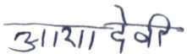

Signature (Ashadevi Ray)



# House Rent Receipt

### Dated: 1/5/2022

This is to acknowledge the receipt from **Virendrakumar Rai** the sum of rupees **32000/-** (Rs. thirty two thousand only) towards rent payment for the month of May 2021 , towards the property bearing the address "COS Ankita Co.Op.Housing Society Limited, Thakurli East ,Thane-421021"

### Owner's Name and Address

Ashadevi Ray

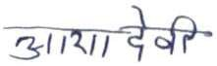B05 Ankita Nagari Co.Op.Housing Society Limited, Thakurli East ,Thane-421021 Pan: DXUPR3739B

### Owner's Name and Address

Ashadevi Ray

B05 Ankita Nagari Co.Op.Housing Society Limited, Thakurli East ,Thane-421021 Pan: DXUPR3739B



# House Rent Receipt

### Dated: 1/7/2022

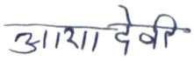

## Signature (Ashadevi Ray)



This is to acknowledge the receipt from **Virendrakumar Rai** the sum of rupees **32000/-** (Rs. thirty two thousand only) towards rent payment for the month of July 2021 , towards the property bearing the address "COS Ankita Co.Op.Housing Society Limited, Thakurli East ,Thane-421021"

### Owner's Name and Address

Ashadevi Ray

B05 Ankita Nagari Co.Op.Housing Society Limited, Thakurli East ,Thane-421021 Pan: DXUPR3739B

### Owner's Name and Address

Ashadevi Ray

B05 Ankita Nagari Co.Op.Housing Society Limited, Thakurli East ,Thane-421021 Pan: DXUPR3739B



Signature (Ashadevi Ray)

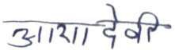

# House Rent Receipt

### Dated: 1/9/2022

This is to acknowledge the receipt from **Virendrakumar Rai** the sum of rupees **32000/-** (Rs. thirty two thousand only) towards rent payment for the month of September 2021 , towards the property bearing the address "C08 Ankita Co.Op.Housing Society Limited, Thakurli East,Thane-421021"

### Owner's Name and Address

Ashadevi Ray

B05 Ankita Nagari Co.Op.Housing Society Limited, Thakurli East ,Thane-421021 Pan: DXUPR3739B

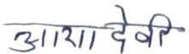

Signature (Ashadevi Ray)

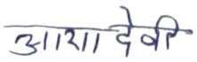

# House Rent Receipt

### Dated: 1/11/2022

This is to acknowledge the receipt from **Virendrakumar Rai** the sum of rupees **32000/-** (Rs. thirty two thousand only) towards rent payment for the month of November 2021 , towards the property bearing the address "C08 Ankita Co.Op.Housing Society Limited, Thakurli East,Thane-421021"

### Owner's Name and Address

Ashadevi Ray

B05 Ankita Nagari Co.Op.Housing Society Limited, Thakurli East ,Thane-421021 Pan: DXUPR3739B

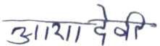

Signature (Ashadevi Ray)



# House Rent Receipt

### Dated: 1/1/2023

This is to acknowledge the receipt from **Virendrakumar Rai** the sum of rupees **32000/-** (Rs. thirty two thousand only) towards rent payment for the month of January 2022 , towards the property bearing the address "C08 Ankita Co.Op.Housing Society Limited, Thakurli East,Thane-421021"

### Owner's Name and Address

Ashadevi Ray

B05 Ankita Nagari Co.Op.Housing Society Limited, Thakurli East ,Thane-421021 Pan: DXUPR3739B



# House Rent Receipt

### Dated: 1/3/2023



## Signature (Ashadevi Ray)

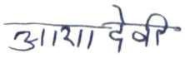

This is to acknowledge the receipt from **Virendrakumar Rai** the sum of rupees **32000/-** (Rs. thirty two thousand only) towards rent payment for the month of March 2022, towards the property bearing the address "C08 Ankita Co.Op.Housing Society Limited, Thakurli East ,Thane-421021"